Roll No. .......................................
MATM2215T: MATHEMATICAL METHODS
Maximum Marks: 70 Time Allowed: 3 Hours
Note: Attempt two questions (out of four) each from Section A and Section B, carrying 10 marks each, and the entire Section C, consisting of 10 short questions carrying 3 marks each.
Section A
- Reduce the following Initial Value Problem 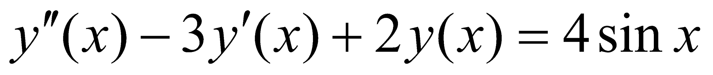
into volterra Integral Equation of Second Kind with initial conditions . Derive the original differential equation also from the integral equation. (10)
- (i) Prove that the mth iterated kernel K_{m}(x, t) satisfies the relation
dt where r is any positive integer less than m. (5)
(ii) Solve the Fredholm Integral Equation 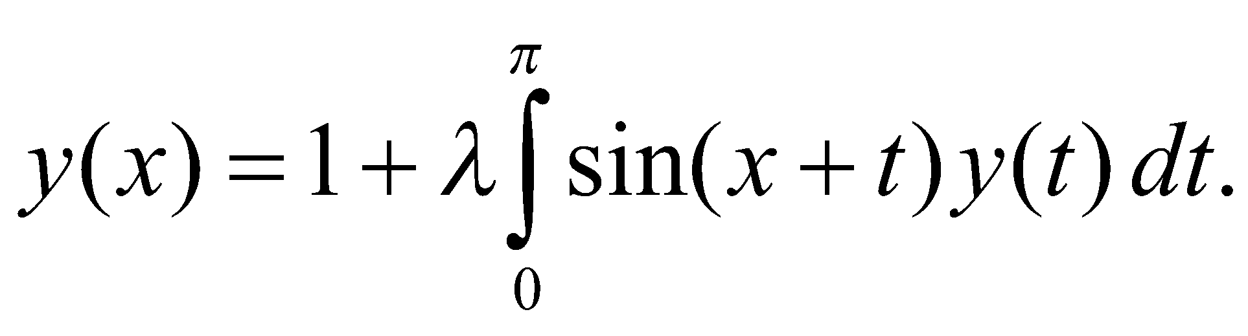 (5)
- Derive Fredholm’s two Fundamental R elations. (10)
- (i) Explain the Volterra’s Solution of fredholm integral equation of second kind (5)
(ii) Explain Fredholm Solution of Neumann Problem. (5)
Section B
- (i) Derive Euler – Lagrange equation . (5)
(ii) State and prove End –Point Problem.
- (i) Explain Brachistochrone Problem. (5)
(ii) Find the shortest distance between P(0, 0) and the straight line x+y=
(5)

- (i) Find Geodesics of Right circular cone. (5)
(ii) Find extremal of ; 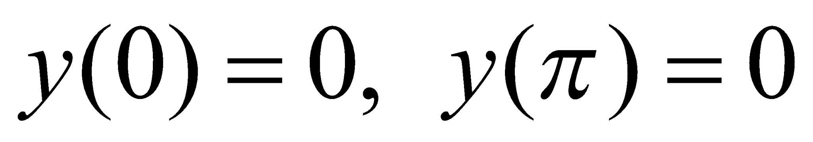 . (5)
- (i) Find the extremals of the functional (5)
(ii) Explain Variational Derivative. (5)
Section C

- Attempt all questions:
- Define Abel’s problem.
- Find iterated kernels for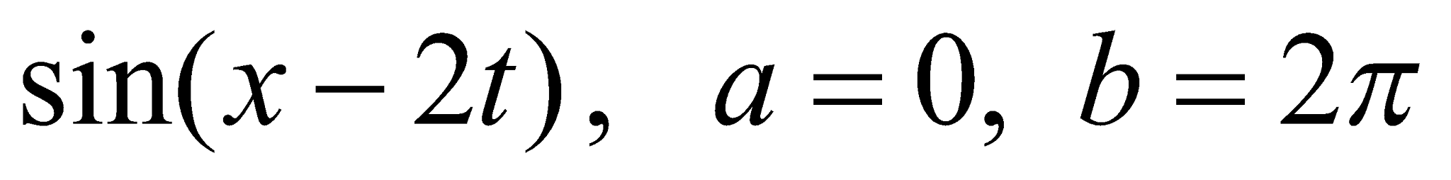.
- Find the resolvent kernel for 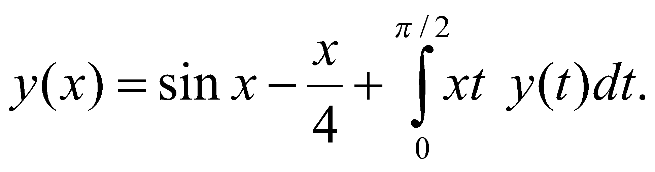
- Define Eigen Values and Eigen Function for an integral equation.
- Find the extremal of with y(1)=0 and y(2)=1
- Show that the shortest distance between two points in a plane is a straight line.
- State Schwarz’s Inequality.
- Prove D(x,t:λ) is a convergent series.
- Define Reciprocal Kernel.
- Derive Euler’s Lagrange equation when f is independent of x.
(10 x 3 = 30)
Roll No. .......................................
MATM2215T: MATHEMATICAL METHODS
Maximum Marks: 70 Time Allowed: 3 Hours
Note: Attempt two questions (out of four) each from Section A and Section B, carrying 10 marks each, and the entire Section C, consisting of 10 short questions carrying 3 marks each.
Section A
- Reduce the following Initial Value Problem
into volterra Integral Equation of Second Kind with initial conditions . Derive the original differential equation also from the integral equation. (10)
- (i) Prove that the mth iterated kernel K_{m}(x, t) satisfies the relation
dt where r is any positive integer less than m. (5)
(ii) Solve the Fredholm Integral Equation (5)
- Derive Fredholm’s two Fundamental Relations. (10)
- (i) Explain the Volterra’s Solution of fredholm integral equation of second kind (5)
(ii) Explain Fredholm Solution of Neumann Problem. (5)
Section B
- (i) Derive Euler – Lagrange equation . (5)
(ii) State and prove End –Point Problem.
- (i) Explain Brachistochrone Problem. (5)
(ii) Find the shortest distance between P(0, 0) and the straight line x+y=
(5)

- (i) Find Geodesics of Right circular cone. (5)
(ii) Find extremal of ; . (5)
- (i) Find the extremals of the functional (5)
(ii) Explain Variational Derivative. (5)
Section C

- Attempt all questions:
- Define Abel’s problem.
- Find iterated kernels for.
- Find the resolvent kernel for
- Define Eigen Values and Eigen Function for an integral equation.
- Find the extremal of with y(1)=0 and y(2)=1
- Show that the shortest distance between two points in a plane is a straight line.
- State Schwarz’s Inequality.
- Prove D(x,t:λ) is a convergent series.
- Define Reciprocal Kernel.
- Derive Euler’s Lagrange equation when f is independent of x.
(10 x 3 = 30)

